**Challenge 4 Instructions**

**Student Learning Outcomes:**

1. Develop skills with use of a handheld oscilloscope, the DSO Shell, to measure DC voltage.

2. Develop skill with calculating current with measured voltage and calculated equivalent resistance using ohm’s law.

3. Develop skill with setting up simple analog circuits on a breadboard.

4. Measure a time response curve (v-t) for an RC circuit subject to a DC Voltage.

**Background:**

Read the documents provided in the lab kits to ensure you are ready to take on the Lab Challenge 4. These documents include user manuals for the handheld oscilloscope and the lab kits guidelines (Lab Kits – Equipment Safety and Good Practices). It is strongly suggested that to do research on the web and find helpful materials such as files that detail resistance and capacitor codes, videos that teaches you how to use a breadboard and power supply module. You can also review equations from your ECE Circuits course to ensure you can predict values for current, voltage, and resistance in a circuit meanwhile ensuring your measurements during lab make sense to you.

Required Activities (You determine the experiment design and process):

Notes: (1) In this and all subsequent measurements, be sure to record the data to the highest precision available from the instrument.

**Activity 1) Series and Parallel Resistor Circuit, acting as a voltage divider**

Analyze and then construct the series-parallel resistive circuit shown. First predict what you think will happen, by developing analytical equations in parametric form.

**1) Take a picture of your constructed circuit and attach it in your working notes.**

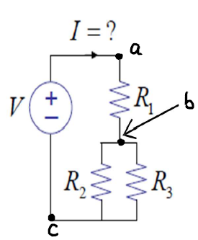

|  |
| --- |
| 1. **Calculating equivalent Resistance**   Calculated R bc =  Calculated R ac = |

Locate resistors R1, R2, and R3 in your ‘Upgraded Electronics Fun Kit’, they should be 10kΩ, 100kΩ, and 100kΩ, respectively. Document their color codes. **3) Using your choice of resistance code charts, write down the process of how you read the color code for each resistance.** (Hint: these are 5 band code resistors). Calculate the equivalent resistances for node bc and ac, and fill in the chart above.

Using the power supply module, connect an input voltage of +5 volts to the circuit above (across points a and c). **4) Calculate and measure the voltages across the points indicated.**

|  |
| --- |
| Calculated V ab = Measured V ab =  Calculated V bc = Measured V bc = |

Measuring voltage with oscilloscope: turn the switch on top of oscilloscope to ‘DC’. Then connect the BNC/Alligator clamps to the BNC connector next to the switch. The red clamp is the positive, the black clamp is the negative.

**5) Observe and Discuss: Compare your analysis and expected value(s) with what you measure.**

**6) Calculate the current in the circuit at node a.**

|  |
| --- |
| Calculated I = |

**Activity 2) Wheatstone Bridge Circuit**

Analyze and then construct the circuit shown with the indicated nominal R values shown in the table. Use the 5v supply for Vsource. **7) Calculate and Measure the voltage across BC for each version of the circuit, Q1 and Q2.**

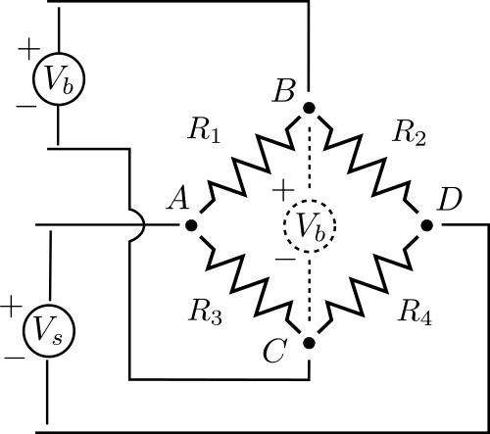

|  |  |  |  |  |  |  |
| --- | --- | --- | --- | --- | --- | --- |
| **Q#** | **R1**  **[kΩ]** | **R2**  **[kΩ]** | **R3**  **[kΩ]** | **R4**  **[kΩ]** | **Calculated V [V]** | **Measured**  **V [V]** |
| **1** | **2** | **1** | **2** | **1** |  |  |
| **2** | **2** | **1** | **2** | **Two 1 kΩ in parallel** |  |  |

**8) Take a picture of your constructed circuit and attach it in your working notes.**

**Activity 3) Time Response of a Capacitor Circuit**

Analyze and construct the circuit shown, being sure to **orient the capacitor correctly**. Before connecting the power supply to the circuit, make sure the capacitor is fully discharged by shorting across its leads (you can simply apply a secondary jumper wire to create this shorting effect). You are to collect data that demonstrates the charging time of the capacitor. **9) Take a picture of your constructed circuit and attach it in your working notes.**

|  |
| --- |
| R = 500kΩ (two 1M in parallel)  C = 100 μF (find it in the circuit kit)  V = 5 V (using power supply module) |

|  |
| --- |
| A “suggested” procedure that you can adapt includes:   * Immediately after connecting the power supply, measure the voltage across the capacitor as a function of time at XX-second intervals for the first X minutes and at YY second intervals thereafter for Y additional minutes, which should be sufficient to charge the capacitor near its maximum value. * Try different time intervals and total duration of your choosing, being sure to discharge the capacitor before each cycle. * **10) Record the obtained data, and plot the charging curve (voltage vs. time) for the capacitor in a spreadsheet.** * As time permits, try capturing the discharge cycle as well. |

